Bahria University,

Karachi Campus



LAB EXPERIMENT NO.

**04**

LIST OF TASKS

|  |  |
| --- | --- |
| TASK NO | OBJECTIVE |
| 1 | 1. Display Product’s name and their supplier’s name (ContactName), whose supplier’s name does not contain “A” and there should be at most 10 characters in Product’s name. 2. Create a report showing order ID., OrderDate, EmployeeID, and the firstname and LastName of the associated Employee. (Tables: Employees & Orders ) 3. Count no of Products’s against each Suppliers name. List only those products whose count is less than 5. 4. Display Titles and their quantity. Show only those records where quantity is less than 10 (Hint Pubs database, table title and sales). 5. Display Book Title and publisher Names (pubs Database, Table Title and Publisher). 6. Display name of those publishers who haven’t published any book yet. 7. Display Authors name whose city is same (Author id should be different). 8. Use cross join (Cartesian join) to Display Book Title and Publisher Name. 9. Use two full joins to Display Product Name, Category Name and Supplier Name. 10. Write a query to list the names of employees that belongs to the same location as the employee named Nancy. |

Submitted On:

**Date: ___4-3-2024__**

**Exercise**

1. **Display Product’s name and their supplier’s name (ContactName), whose supplier’s name does not contain “A” and there should be at most 10 characters in Product’s name.**

**Solution:**

use Northwind;

SELECT p.ProductName, s.ContactName AS SupplierName

FROM Products p

INNER JOIN Suppliers s ON p.SupplierID = s.SupplierID

WHERE LEN(p.ProductName) <= 10

AND s.ContactName NOT LIKE '%A%'

**Output:**

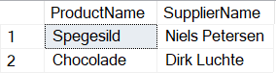

1. **Create a report showing order ID., OrderDate, EmployeeID, and the firstname and LastName of the associated Employee. (Tables: Employees & Orders )**

**Solution:**

use Northwind;

SELECT o.OrderID, o.OrderDate, o.EmployeeID, e.FirstName, e.LastName

FROM Orders o

INNER JOIN Employees e ON o.EmployeeID = e.EmployeeID;

**Output:**

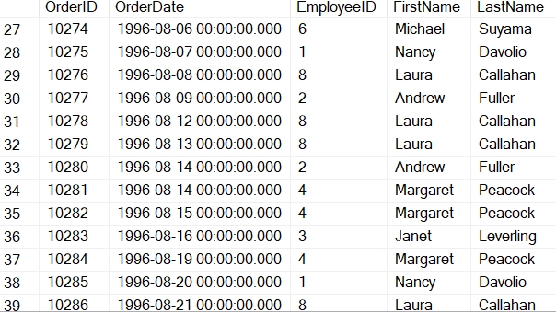

1. **Count no of Products’s against each Suppliers name. List only those products whose count is less than 5.**

**Solution:**

use Northwind;

SELECT s.CompanyName AS SupplierName, COUNT(p.ProductID) AS ProductCount

FROM Products p

INNER JOIN Suppliers s ON p.SupplierID = s.SupplierID

GROUP BY s.CompanyName

HAVING COUNT(p.ProductID) < 5;

**Output:**

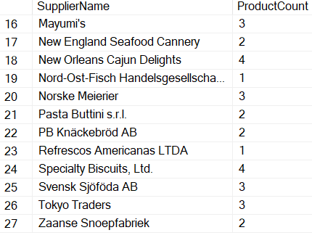

1. **Display Titles and their quantity. Show only those records where quantity is less than 10 (Hint Pubs database, table title and sales)**

**Solution:**

use pubs;

SELECT t.title, s.qty

FROM titles t

INNER JOIN sales s ON t.title_id = s.title_id

WHERE s.qty < 10;

**Output:**

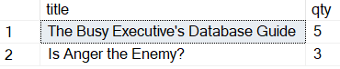

1. **Display Book Title and publisher Names (pubs Database, Table Title and Publisher).**

**Solution:**

use pubs;

SELECT t.title AS BookTitle, p.pub_name AS PublisherName

FROM titles t

INNER JOIN publishers p ON t.pub_id = p.pub_id;

**Output:**

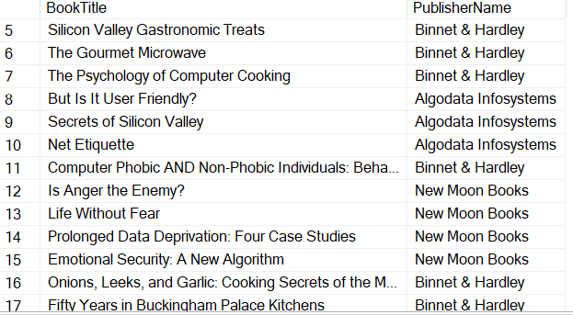

1. **Display name of those publishers who haven’t published any book yet.**

**Solution:**

use pubs;

SELECT p.pub_name AS PublisherName FROM publishers p LEFT JOIN titles t ON p.pub_id = t.pub_id WHERE t.pub_id IS NULL;

**Output:**

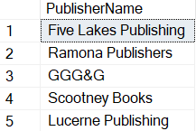

1. **Display Authors name whose city is same (Author id should be different).**

**Solution:**

use pubs;

SELECT DISTINCT a1.au_fname AS AuthorFirstName1, a1.au_lname AS AuthorLastName1,

a2.au_fname AS AuthorFirstName2, a2.au_lname AS AuthorLastName2

FROM authors a1

INNER JOIN authors a2 ON a1.city = a2.city AND a1.au_id <> a2.au_id;

**Output:**

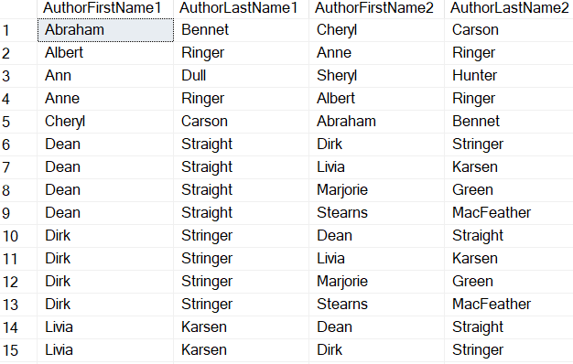

1. **Use cross join (Cartesian join) to Display Book Title and Publisher Name.**

**Solution:**

use pubs;

SELECT t.title AS BookTitle, p.pub_name AS PublisherName

FROM titles t

CROSS JOIN publishers p;

**Output:**

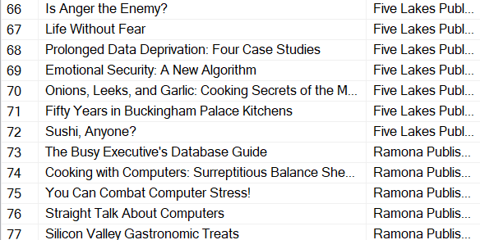

1. **Use two full joins to Display Product Name, Category Name and Supplier Name.**

**Solution:**

use Northwind;

SELECT

p.ProductName,

c.CategoryName,

s1.CompanyName AS SupplierName

FROM

Products p FULL JOIN Categories c ON p.CategoryID = c.CategoryID FULL JOIN Suppliers s1 ON p.SupplierID = s1.SupplierID;

**Output:**

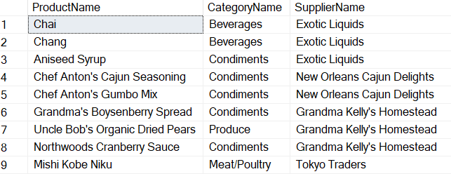

1. **Write a query to list the names of employees that belongs to the same location as the employee named Nancy.**

**Solution:**

use Northwind;

SELECT FirstName + + LastName [Employee Name]

FROM Employees

WHERE City = (SELECT City FROM Employees WHERE FirstName = 'Nancy');

**Output:**

